##### GAMING NEWS PORTAL

##### A PROJECT REPORT

***Under the guidance of***

**Khagendra Shah**

***Submitted by***

### Pratik Baishnav

*In partial fulfillment of the requirement for the award of the degree*

*Of*

**B.Sc.IT Third Semester**



21-January-2016

**College for Professional Studies**

**LC of Sikkim Manipal University (01537)**

### VIVA VOCE SHEET

We have examined the viva-voce examination of the graduate research report presented by

**Pratik Baishnav**

Entitled

**GAMING NEWS PORTAL**

And found the report to be original work of the student and written according to the prescribed format of the University. We recommend the report to be accepted as partial fulfillment of the requirements for the B.Sc.IT Third semester.

**Viva-Voce Committee**

1. Supervisor/Project Guide

1. Program Coordinator
2. Chief Program Coordinator
3. External Examiner

Date: 21 January 2016

### 

### BONAFIDE CERTIFICATE

Certified that this project report titled**“GAMING NEWS PORTAL”** is bonafide work of **“Pratik Baishnav”**who carried out the project work under my supervision.

**CERTIFIED**

**………………………………..**

**Khagendra Shah**

**Project Supervisor**

Department of Computer Science

College for Professional Studies

LC of Sikkim Manipal University

LC Code: 01537

### 

### Certificate from University Learning Centre

This is to certify that **Pratik Baishnav** of B.Sc.IT has worked on the project as per the course curriculum of B.Sc.IT Third Semester. This project entitled “**GAMING NEWS PORTAL**” is the original work of Pratik Baishnav and was carried out under the supervision of **Khagendra Shah** as per the guidelines provided by the university. As per the student’s declaration this is certified that his projecthas not been presented anywhere as a part of any other academic work.

**………………………**

**P.Kejriwal**

**Founder**

**………………………**

**Er. PankajJalan**

**Executive (Director)**

**………………………**

**Er. Prakash Kumar**

**Director (Academics)**

### 

### Certificate from University Learning Centre

This is to certify that **Pratik Baishnav** of B.Sc.IT has worked on the project as per the course curriculum of B.Sc.IT Third Semester. This project entitled “**GAMING NEWS PORTAL**” is the original work of **Pratik Baishnav** and was carried out under the supervision of **Khagendra Shah** as per the guidelines provided by the university. As per the student’s declaration this is certified that his project has not been presented anywhere as a part of any other academic work.

**………………………**

**Prof. Dr. Mahendra Singh**

**Chief Academic Advisor**

**………………………**

**Ramesh Suwal**

**Program Coordinator**

**………………………**

**Uday Kant Jha**

**Chief Coordinator**

### Student declaration

I hereby declare that the project report entitled

**GAMING NEWS PORTAL**

Submitted in partial fulfillment of the requirements for the degree of

B.Sc.IT Third Semester

To Sikkim-Manipal University, India, is my original work and not submitted for the award of any other degree, diploma, fellowship, or any other similar title or prizes

Place: Kathmandu Pratik Baishnav

Date: 21-January-2016 Reg. No: 551217295

### 

### ACKNOWLEDGEMENT

I consider it a privilege to express through these pages of this report, a few words of gratitude and respect to all who guided and inspired me in completion of this project. The successful accomplishment of this project work requires efforts of several intellect minds. Several people have contributed their experiences and ideas to make this project.

Words appear inadequate and hollow, when I take this opportunity to express my deep sense of gratitude to “**Er. Pankaj Jalan”,** the administrator Director of CPS College, to “**Er. Prakash Kumar**”, the academic director, to “**Mr. Uday Kant Jha**”, the program coordinator, to my respectable project guides “**Mr. KhagendraSah**” and respectable teachers **Mr. Sanjeev Subedi** and **Mr. Chandra Kishor Gauro** and all the teachers and staff for their cooperation and coordination in providing necessary information and resources for our project. Especially I like to thank to **Mr. LaxmanSubedi** for inspiration and proper guidance.

I express my sincere thanks to my classmates, friends and my family my brother Pukar Baishnav for the most for relentless support and help to make this project as it is should be. And at last but not the least I would like to thank my close friends Bikash Shrestha, Sunil Shrestha, Seeba Shrestha, Prasanga Poudel, Pasang Norbu Lama, Sazeed Shakya, Sushila Chhunju and so on for support and providing me different ideas and their valuable time for this project. I thank all the people for their help directly and indirectly to complete my minor project. Thank You.

**Pratik Baishnav**

**B.Sc.IT Third Semester**

**Roll no: 551217295**

### 

### ABSTRACT

Online news portal helps towards changeover of a traditional paper based news into an online news. This transition will benefit a local newspaper publisher to gain global audience as well as benefit from the diverse features of internet like multimedia integration, search ability and social sharing. Nepal has dozens of news portal and it has been popular among Nepali internet users in couple of years. This report attempts to introduce the brief information of computer games news. The literature review of this report states a brief function of the news portal. Unified System Development Process is the methodology used in this project and reason to use this methodology is explained. Moreover, this report has track of progress with the reference from provided Gantt chart and further tasks.

This project entitled “GAMING NEWS PORTAL” is a minor project work for partial fulfillment of B.Sc.IT Third Semester. It is a small website which is helpful to provide news over the internet. This project is database oriented program and it is developed using XAMPP and ADOBE DREAMWEAVER(PHP).

Hence, this website is helpful for the people who wants to track the latest information of computer games. This project is also a small step towards development of big professional website.

**Table of Content**

1.Title Page I

2. VIVA VOCE SHEET II

3. BONAFIDE CERTIFICATE III

4. Certificate from University Learning Centre IV

5. Certificate from University Learning Centre V

6. Student declaration VI

7. ACKNOWLEDGEMENT VII

8. ABSTRACT VIII

9. Chapters 4

1. Introduction 4

2. Objective/Scopes on GAMING NEWS PORTAL 4

3. THEORETICAL BACKGROUND 5

4. DEFINITION OF PROBLEM 6

5. FEASIBILITY STUDY 7

6. SYSTEM PLANNING 8

6.1 Gantt Chart 8

7. METHODOLOGY ADOPTED 9

7.1 Project Methodology 9

7.2 Hardware and Software Used 12

8. LIFE CYCLE OF PROJECT 13

8.1 System Architecture Overview 13

8.2 Testing Method 16

9. DATA DICTONARY 22

9.1. Schemas 22

10. SNAPSHOTS AND CODE OF PROJECT 25

10.1 SNAPSHOTS 25

10.2 CODES 30

11. USER OPERATIONS AND MANUAL 57

11.1 Support and Maintenance 57

11.2 Future Scope 58

11.3 Backup and Recovery 59

11.4 Security 59

12. Conclusion and Recommendation 60

13. Bibliography 61

**LIST OF TABLES**

table 1: Table_Aboutus 22

table 2: Table_Category 22

table 3: Table_Help 23

table 4: Table_Log 23

table 5: Table_News 23

table 6: Table_Users 24

**LIST OF FIGURES**

Figure 1: ER Diagram 13

Figure 2: Context Level DFD 14

Figure 3: Flow Chart 15

Figure 4: Login Page 25

Figure 5: Visitor Page 25

Figure 6: Admin Page 26

Figure 7: Member page 26

Figure 8: Watch all news page 27

Figure 9: Add News Page 27

Figure 10: manage news page 28

Figure 11: Change Self Details 28

Figure 12: manage user page 29

Figure 13: about us page 29

**Abbreviation**

DFD = Data Flow Diagram

ERD = Entity Relationship Diagram

XAMPP = My Structured Query Language

B.Sc.IT = Bachelors of Science in Information Technology

IT = Information Technology

SMU = Sikkim Manipal University

CPS = College for Professional Studies

LBEF = Lord Buddha Education Foundation

# 

# 9. Chapters

## 1. Introduction

GAMING NEWS PORTAL is user based small website. GAMING NEWS PORTAL is focused for areas like institutes and for different users which offer informations on different games and made for providing details and information over the internet. This website is very useful to provide games information.

The project is entitled “GAMING NEWS PORTAL” and before discussing anything about the project GAMING NEWS PORTAL, a brief discussion of related basic concept is necessary.

As a webiste developer or as a programmer, we are expected to design and developed any website that works correctly, efficiently and the time is easy to be used by every person, who may or may not be well versed with computer and its capabilities.

The Project is based on the GAMING NEWS PORTAL, Being the Information System it requires extensive use of some Data base Management System to store, manipulate and handle the huge and complex record, In RDBMS we can act various attributes with the database like editing the records, Modifications Deletions of the records, View the records in various formats, listing the database etc. Project can be categorized by their functioning and relation with their database and other tools can categorize project. Since this project has been developed based on the Relation Data Base Management System So Proposed system comes under RDBMS (Relational Database Management System) category, as there is need to store and manipulate a huge amount of data related to patients as per various queries.

## ****2. Objective/****Scopes****on GAMING NEWS PORTAL****

This is ADOBE DREAMWEAVER(PHP) Project on GAMING NEWS PORTAL, which provided a lot of facility to their user. The objective and scope of my Project GAMING NEWS PORTAL is to record the details of various information of game. It will simplify the task and reduce the paper work. During implementation every user will be given appropriate training to suit their specific needs. Specific support will also be provided at key points within the academic calendar. Training will be provided on a timely basis, and you will be trained as the new user of GAMING NEWS PORTAL rolled out to your area of responsibility.

At the moment we are in the very early stages, so it is difficult to put a specific time on the training, but we will keep people informed as plans are developed. The system is very user friendly and it is anticipated that functions of the system will be easily accessed by administrators and user staffs.

Hence the website for the information management has been designed to remove all the deficiency from which the present system is suffering and to ensure.

## 3. THEORETICAL BACKGROUND

The project is entitled “GAMING NEWS PORTAL” and before discussing anything about the project GAMING NEWS PORTAL, a brief discussion of related basic concept is necessary.

As a website developer or as a programmer, we are expected to design and developed any program that works correctly, efficiently and the time is easy to be used by every person, who may or may not be well versed with computer and its capabilities.

The Project is based on the GAMING NEWS PORTAL, Being the Information System it requires extensive use of some Database Management System to store, manipulate and handle the huge and complex record, In RDBMS we can act various attributes with the database like editing the records, Modifications Deletions of the records, View the records in various formats, listing the database etc. Project can be categorized by their functioning and relation with their database and other tools can categorize project. Since this project has been developed based on the Relation Data Base Management System So Proposed system comes under RDBMS (Relational Database Management System) category, as there is need to store and manipulate a huge amount of data related to patients as per various queries.

## 

## 4. DEFINITION OF PROBLEM

The existing system only provides text-based interface, which is not as user-friendly as Graphical user Interface. Since the system is implemented in Manual, so the response is very slow. The transactions are executed in on-line mode, hence off-line data capture and modification is not possible. Off-line reports cannot be generated.

Hence, there is a need of reformation of the system with more advantages and flexibility. The GAMING NEWS PORTAL eliminates most of the limitations of the existing software. It has the following objectives:

**Enhancement:**

The main objective of GAMING NEWS PORTAL is to enhance and upgrade the existing system by increasing its efficiency and effectiveness. The website improves the working methods by replacing the existing manual system with the computer-based system.

**Automation:**

The GAMING NEWS PORTAL automates each and every activity of the manual system and increases its throughput. Thus the response time of the system is very less and it works very fast.

**Accuracy:**

The GAMING NEWS PORTAL provides the uses a quick response with very accurate information regarding the users etc. Any details or system in an accurate manner, as and when required.

**User-Friendly:**

The software GAMING NEWS PORTAL has a very user-friendly interface. Thus the users will feel very easy to work on it. The software provides accuracy along

with a pleasant interface. Make the present manual system more interactive, speedy and user friendly.

**Availability:**

The transaction reports of the system can be retried as and when required. Thus, there is no delay in the availability of any information, whatever needed, can be captured very quickly and easily.

**Maintenance Cost:**

Reduce the cost of maintenance.

## 5. FEASIBILITY STUDY

The feasibility study is an evaluation and analysis of the potential of a proposed project which is based on extensive investigation and research to support the process of decision making. It aim to objectively and rationally uncover the strengths and weaknesses of an existing business or proposed venture, opportunities and threats present in the environment, the resources required to carry through, and ultimately the prospects for success. In its simplest terms, the two criteria to judge feasibility are cost required and value to be attained.

Feasibility study conducted once problem is clearly understood. There are three types of feasibility study: technical feasibility, operational feasibility, economic feasibility.

**Technical feasibility:**

A technical feasibility study of function, performance and constraints can affect the ability to achieve an acceptable system. The software developed for managing GAMING NEWS PORTAL is used in computer as application software with ADOBE DREAMWEAVER(PHP) as front end and XAMPP Server as back end so the project is technically feasible.

**Operational feasibility:**

The main purpose of this website is to develop a Web based website which facilitates on providing computer based or electronic based system replacing old paper work system. No computer trainings or experts are needed to handle this website. Therefore this project is operational feasible.

**Economic feasibility:**

Economic feasibility analysis includes a broad range of tests that include long term cooperative income strategies, cost of resources needed for development, cost benefit analysis. In existing system they had to maintain many registers/books is a costly affair. This can be reduced by keeping data in the digital format that is reliable and cheaper .Since the development cost for system satisfies the organization therefore the software is economically feasible.

## 6.SYSTEM PLANNING

### 6.1 Gantt Chart

|  |  |  |  |  |  |  |  |
| --- | --- | --- | --- | --- | --- | --- | --- |
| S.N. | Tasks | Start | End | Duration  (days) | 2015-2016 | | |
| Nov | Dec | Jan |
| 1 | **Analysis** | 02/11/15 | 14/11/15 | 12 |  | | |
| 2 | **Design/coding** | 16/11/15 | 05/12/15 | 34 |  | | |
| 3 | **Documentation** | 10/12/15 | 15/12/15 | 5 |  | | |
| 4 | **Implementation** | 17/12/15 | 24/12/15 | 8 |  | | |
| 5 | **Review** | 01/01/16 | 07/01/16 | 7 |  | | |
| 6 | **Testing** | 07/01/16 | 17/01/16 | 10 |  | | |

## 

## 7. METHODOLOGY ADOPTED

### 7.1 Project Methodology

In software engineering, a methodology refers to software development methodology (also known as software development life cycle), which is a division of software development work into distinct phases or activities with the intent of better planning and management. It may include the pre-definition of specific deliverables and artifacts that are created and completed by a project team to develop or maintain an application.

Project management methodologies are all about specifying the best way to initiate, plan and execute projects. Common methodologies include waterfall prototyping, iterative and incremental development, spiral development, rapid application development and extreme programming.

Several software development approaches have been used since the origin of information technology, in two main categories. Typically an approach or a combination of approaches is chosen by management or a development team. In order to ensure that this project is in par with the objectives, I used the waterfall model approach in developing the systems.

**Waterfall Model**

Waterfall model has evolved from what has been termed more traditional project management methodologies, employing a sequential top-down approach to project management. In a waterfall model, each phase must be completed before the next phase can begin and there is no overlapping in the phases.

The waterfall model illustrates the software development process in a linear sequential flow; hence it also referred to as a linear sequential life cycle model. The waterfall approach, the whole process of software development is divided into six different phases, typically, the outcome of one phase acts as input for the nest phase sequentially.

Following is diagrammatic representation of different phases of waterfall model:

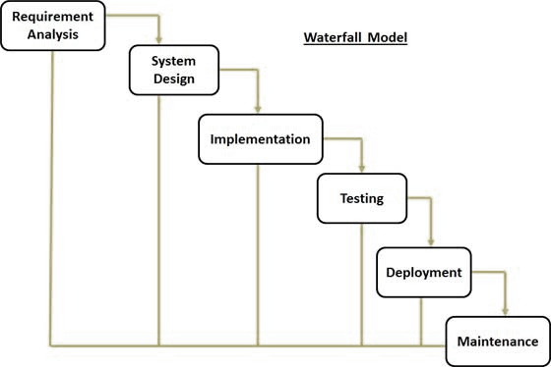

The sequential phases in Waterfall model are:

1. Requirement Analysis

All possible requirements of the system to be developed are captured in this phase and documented in a requirement specification doc.

1. System Design

The requirement specifications from first phase are studied in this phase and system design is prepared. System Design helps in specifying hardware and system requirements and also helps in defining overall system architecture.

1. Implementation

With inputs from system design, the system is first developed in small programs called units, which are integrated in the next phase. Each unit is developed and tested for its functionality which referred to as Unit Testing.

1. Integration and Testing

All the units developed in the implementation phase are integrated into a system after testing of each unit. Post integration the entire system is tested for any faults and failures.

1. Deployment of System

Once the functional and non-functional testing is done, the product is deployed in the customer environment or released into the market.

1. Maintenance

There are some issues which come up with in the client environment. To fix those issues patches are released. Also to enhance the product some better versions are released. Maintenance is done to deliver these changes in the customer environment.

All these phases are cascaded to each other in which progress is seen as flowing steadily downwards (like a waterfall) through the phases. The next phase is started only after the defined set of goals are achieved for previous phase and it is signed off, so the name “Waterfall Model”. In this model, phases do not overlap.

### 

### 7.2 Hardware and Software Used

#### 7.2.1 Hardware Configuration

This system is developed under following hardware configuration:

1. **Intel i3 Personal Computer**
2. **4 GB DDR-III RAM**
3. **500 GB HDD**
4. **Microsoft Compatible Key Board**
5. **Optical Mouse**

#### 7.2.2 Description of Software

This system is developed using the following software:

1. **Operating System : Windows 8.1**
2. **IDE Platform : Adobe Dreamweaver CS6**
3. **Front-End Technology : PHP**
4. **Back-End Technology : XAMPP**

## 

## 

## 8. LIFE CYCLE OF PROJECT

### 8.1 System Architecture Overview

#### 8.1.1 Entity-Relationship Diagram

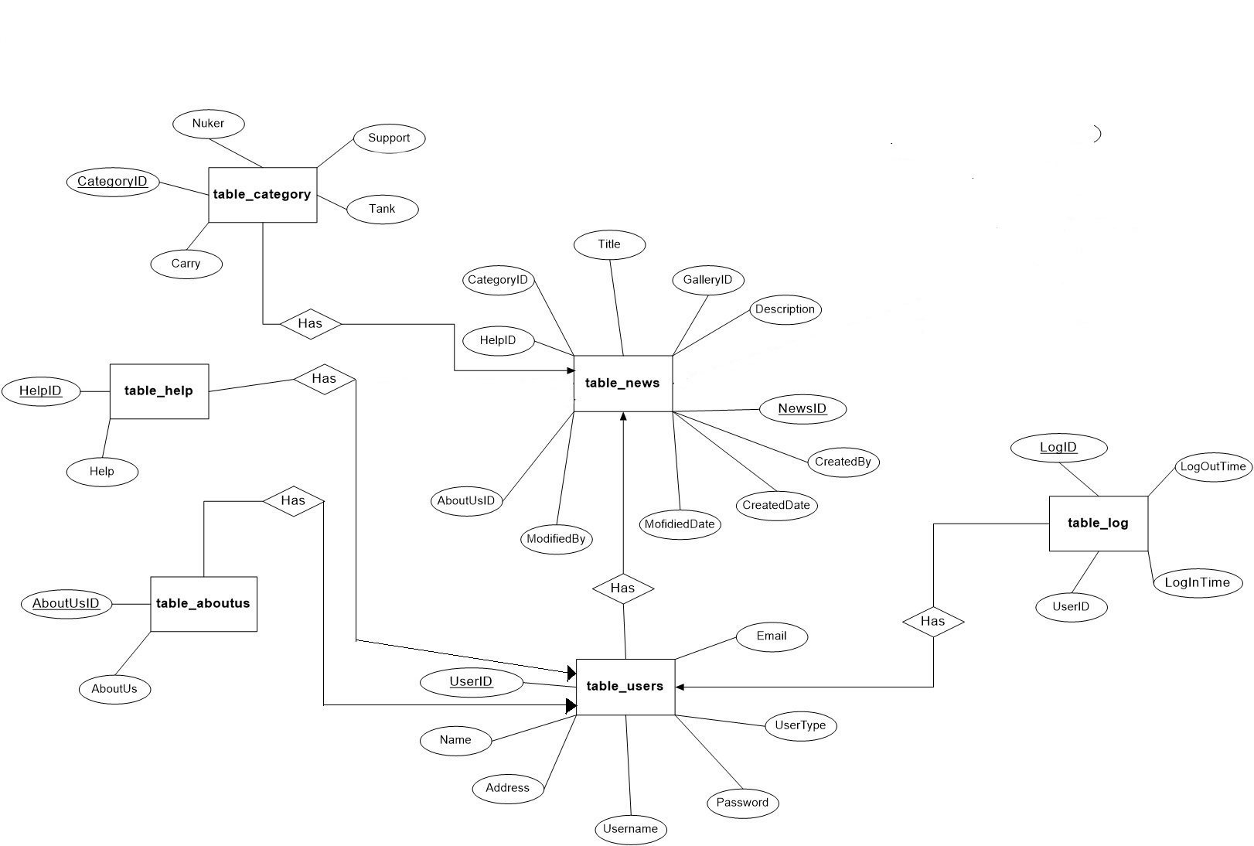

Figure : ER Diagram

#### 8.1.2 Data Flow Diagram

##### 8.1.2.1 Context Level DFD

Figure : Context Level DFD

##### 8.1.3. System Flow Chart

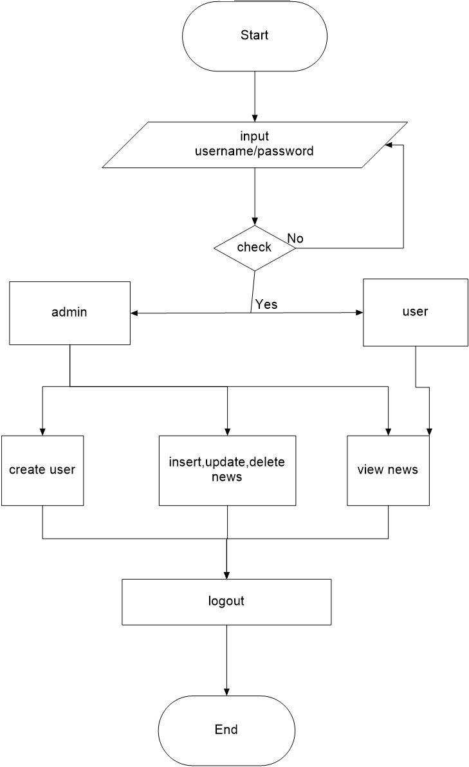

Figure : Flow Chart

### 8.2 Testing Method

Software Testing is an investigation conducted to provide stakeholders with information about the quality of the product or service under test. It can also provide an objective, independent view of the software to allow the business to appreciate and understand the risks of software implementation. Test techniques include, but are not limited to, the process of executing a program or application with the intent of finding software bugs (errors or other defects).

#### 8.2.1 Coding Tools

In software engineering, the terms “front end” and “back end” are distinctions which refer to the separation of concerns between a presentation layer and a data access layer respectively. The front end is an interface between the user and the back end. The front and back ends may be distributed amongst one or more systems.

##### 8.2.1.1 Back End Tools

This activity deals with the design of the physical database. A key is to determine how the access paths art to be implemented.

Program design: In conjunction with database design is a decision on the programming language to be used and the flowcharting, coding, and debugging procedure prior to conversion. The operating system limits the programming languages that will run of the system.

System and program test preparation. Each aspect of the system has a separate test requirement. System testing is done after all programming and testing completed the test on system and program test requirements become a part of design specifications a prerequisite to implementation.

In contrast to the system testing is acceptance testing, which puts the system through a procedure design to convince the user that the proposed system will meet the stated requirements. Acceptance testing is technically similar to system testing but politically it is different.

##### 8.2.1.2 Front End Tools

The systems objectives outlined during the feasibility study serve as the basic from which the work of system design is initiated. Much of the activities involved at this stage are of technical nature requiring a certain degree of experience in designing systems, sound knowledge of computer related technology and through understanding of computers available in the market and the various facilities provided by the vendors. Nevertheless, a system cannot be designed in isolation without the active involvement of the user. The user has a vital role to play at this stage too. As we know that data collected during feasibility study wills we utilized systematically during the system design. It should, however be kept in mind that detailed study of the existing system is not necessarily over with the completion of the feasibility study. Depending on the plan of feasibility study, the level of detailed study will vary and the system design stage will also vary in the amount of investigation that still needs to be done. This investigation is generally an urgent activity during the system. Sometimes, but rarely, this investigation may form a separate stage between feasibility study and computer system design. Designing a new system is a creative process, which calls for logical as well as lateral thinking. The logical approach involves systematic moves towards the end product keeping in mind the capabilities of the personnel and the equipment at each decision making step. Lateral thought implies encompassing of ideas beyond the usual functions and equipment. This is to ensure that no efforts are being made to fit previous solutions into new situations.

##### 8.2.2 Testing Cases

A test case is a set of conditions or variables under which a tester will determine whether a system under test satisfies requirements or works correctly. The process of developing test cases can also help find problems in the requirements or design of an application.

##### Test Case 01

|  |  |  |  |  |  |
| --- | --- | --- | --- | --- | --- |
| Pre-conditions: User run the application and login form displays asking to input correct  Username and password. User inputs correct username and password value.  . | | | | | |
| Step | Action | Expected System Response | P/F | Comment |
| 1 | User inputs value “admin” in both fields. | The system waits user to click button. |  |  |
| 2 | User click on login button | The system runs the Admin form. |  |  |

|  |
| --- |
| Post Condition: The user “admin” is logged in into system. |

##### Test Case 02

|  |
| --- |
| Test Case #: 02 Test Case Name: User Log In Failure  System: Windows 8.1 OS Short Description: Test user fail  Designed by: Pratik Baishnav Design Date: 2015-05-16  Executed by: Pratik Baishnav Execution Date: 2015-05-16 |

|  |
| --- |
| Pre-conditions: User run the application and login form displays asking to input correct  Username and password. User inputs incorrect username and password value.  . |

|  |  |  |  |  |
| --- | --- | --- | --- | --- |
| Step | Action | Expected System Response | P/F | Comment |
| 1 | User inputs value “abcde” in both fields. | The system displays message saying incorrect username and password. |  |  |

|  |
| --- |
| Post Condition: The unauthorized users are not accessed. |

##### Test Case 03

|  |
| --- |
| Test Case #: 03 Test Case Name: Add News  System: Windows 8.1 OS Short Description: Add News  Designed by: Pratik Baishnav Design Date: 2015-05-20  Executed by: Pratik Baishnav Execution Date: 2015-05-20 |

|  |
| --- |
| Pre-conditions: Application is running. In dashboard, user adds new news  in the system. |

|  |  |  |  |  |
| --- | --- | --- | --- | --- |
| Step | Action | Expected System Response | P/F | Comment |
| 1 | User clicks the button and adds news. | The system process the query and adds new news in the database. |  |  |
| 2 | User clicks on the cancel button. | The system cancels to add new news in the database. |  |  |

|  |
| --- |
| Post Condition: As the user adds or cancels to add new news in the database. |

##### Test Case 04

|  |
| --- |
| Test Case #: 04 Test Case Name: add/edit/delete  System: Windows 8.1 OS Description: Test add, edit, delete  Designed by: Pratik Baishnav Design Date: 2015-05-22  Executed by: Pratik Baishnav Execution Date: 2015-05-22 |

|  |
| --- |
| Pre-conditions: The application has different kinds of button for their specific  actions to be performed. And view completion of those action after that. |

|  |  |  |  |  |
| --- | --- | --- | --- | --- |
| Step | Action | Expected System Response | P/F | Comment |
| 1 | User click different action buttons | The system appears edit menu with add, edit and delete buttons. |  |  |
| 2 | User click and modifies data or records | The system updates the data and records and displays it. |  |  |

|  |
| --- |
| Post Condition: The users successfully add, edit and delete records and display it. |

##### Test Case 05

|  |
| --- |
| Test Case #: 05 Test Case Name: modify users  System: Windows 8.1 OS Short Description: Test users  Designed by: Pratik Baishnav Design Date: 2015-05-26  Executed by: Pratik Baishnav Execution Date: 2015-05-26 |

|  |
| --- |
| Pre-conditions: Admin will to modify and add users. |

|  |  |  |  |  |
| --- | --- | --- | --- | --- |
| Step | Action | Expected System Response | P/F | Comment |
| 1 | Admin add, delete | There is user view and admin add or delete specific users. |  |  |
| 2 | Admin modifies users and access type | In same user view, admin can edit user credentials like username, password and user type (here it is of two types: Admin and User) |  |  |

|  |
| --- |
| Post Condition: Users are controlled by Admin and changes credentials. |

## 9. DATA DICTONARY

### 9.1. Schemas

A schema shows the organizational structure of a database. It should show the entities (the tables in the database), and their characteristics (i.e. their properties/attributes/fields). It should clearly identify the primary key in each table and the links and relationships between tables. The example below is just one way a

schema can be represented. There are other acceptable methods that students can use to present this information.

**AboutUs Table**

|  |  |
| --- | --- |
| **Column** | **Data Type** |
| AboutUsID | int |
| AboutUs | varchar(50) |

Table 1: table_aboutus

**Category Table**

|  |  |
| --- | --- |
| **Column** | **Data Type** |
| CategoryID | int |
| CategoryName | varchar(50) |

Table 2: table_category

**Help Table**

|  |  |
| --- | --- |
| **Column** | **Data Type** |
| HelpID | int |
| Help | varchar(50) |

Table 3: table_help

**Log Table**

|  |  |
| --- | --- |
| **Column** | **Data Type** |
| LogID | int |
| UserID | int |
| LogInTime | varchar(50) |
| LogOutTime | varchar(50) |

Table 4: table_log

**News Table**

|  |  |
| --- | --- |
| **Column** | **Data Type** |
| NewsID | int |
| Title | varchar(50) |
| CreatedBy | varchar(50) |
| CreatedDate | varchar(50) |
| Description | mediumtext |
| ModifiedBy | varchar(50) |
| ModifiedDate | varchar(50) |
| Category | varchar(50) |
| ImageName | varchar(200) |

**Table 5: table_news**

**Users Table**

|  |  |
| --- | --- |
| **Column** | **Data Type** |
| UserID | int |
| Name | varchar(50) |
| Username | varchar(50) |
| Password | varchar(50) |
| UserType | varchar(50) |
| Address | varchar(50) |
| Email | varchar(50) |

**Table 6: table_users**

## 

## 10.SNAPSHOTS AND CODE OF PROJECT

### 10.1 SNAPSHOTS

Figure 4: Login Page

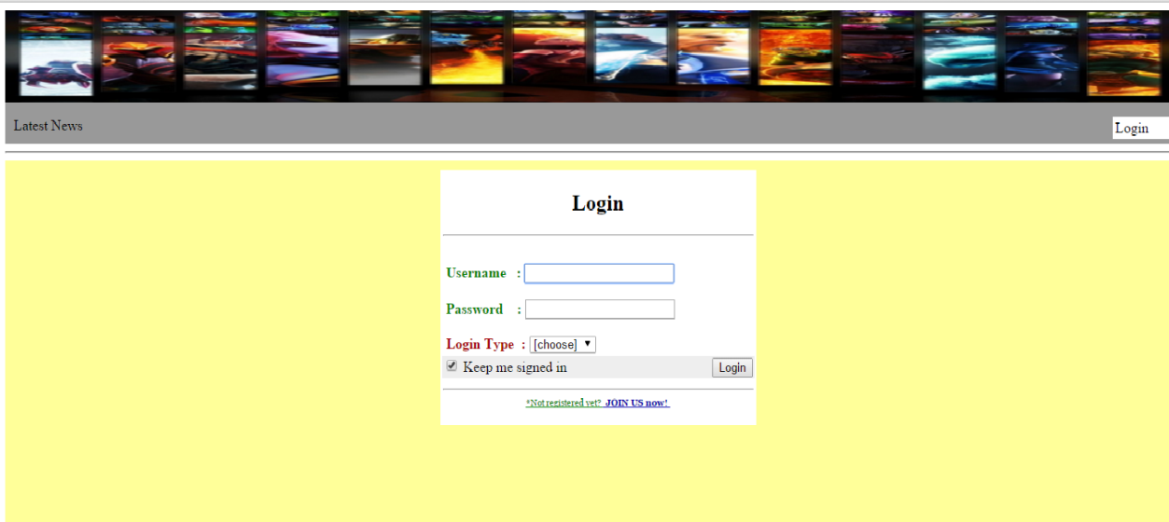

Figure 5: Visitor Page

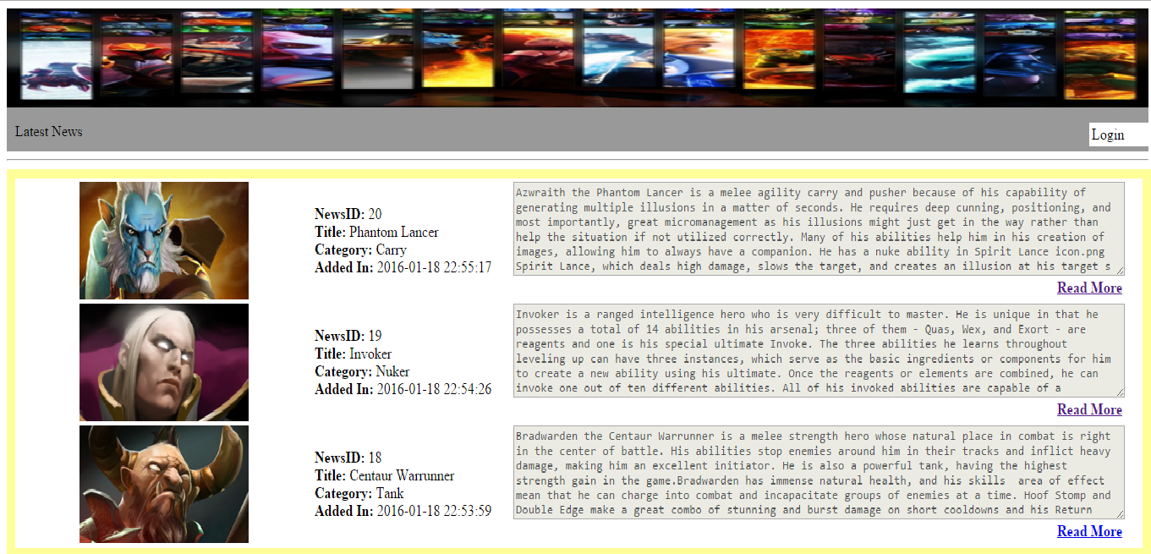

Figure 6: Admin Page

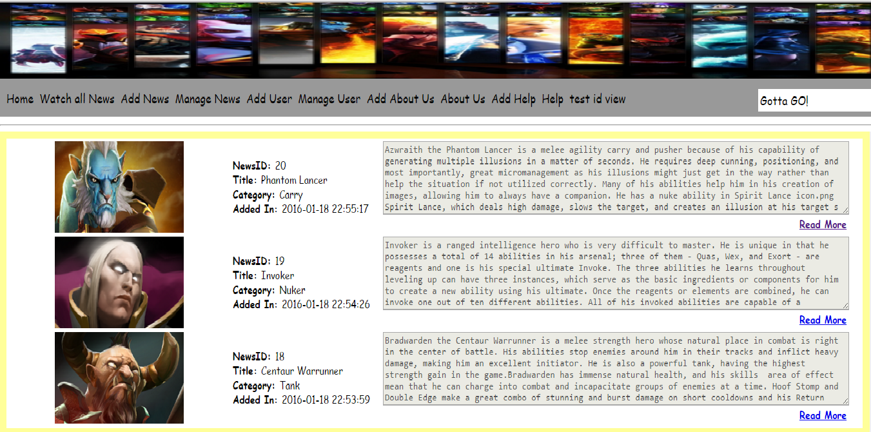

Figure 7: Member Page

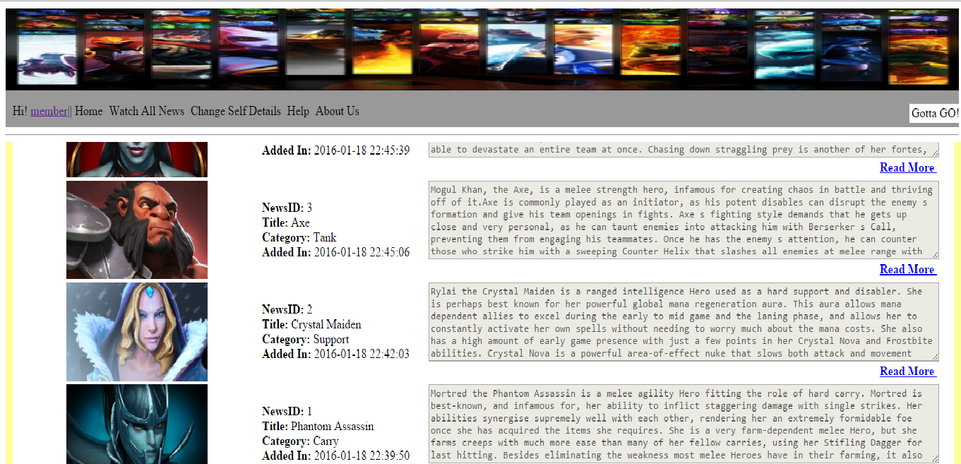

Figure 8: Watch All News Page

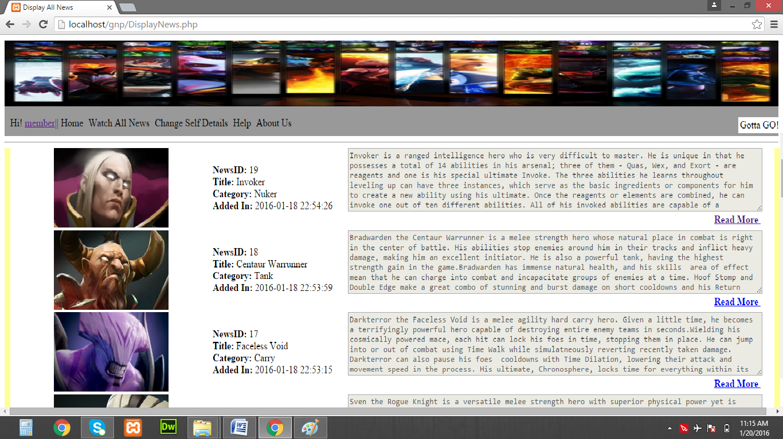

Figure 9: Add News Page

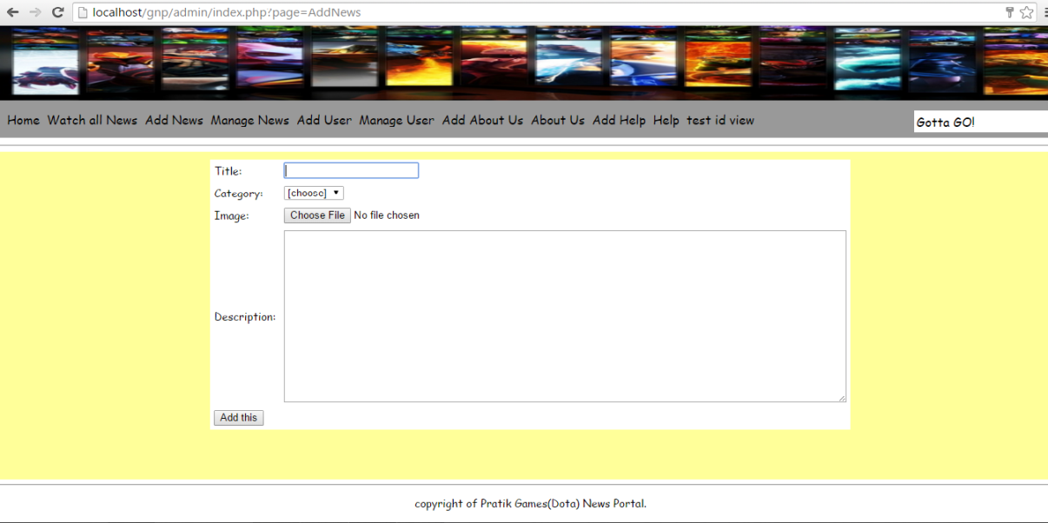

Figure 10: Manage News Page

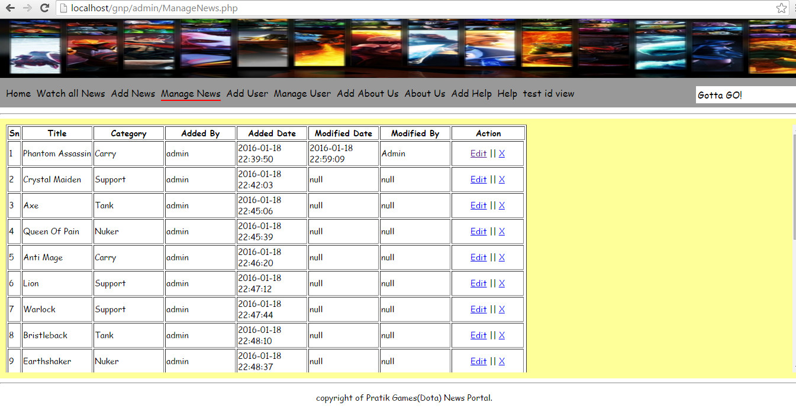

Figure 11: Change Self Details

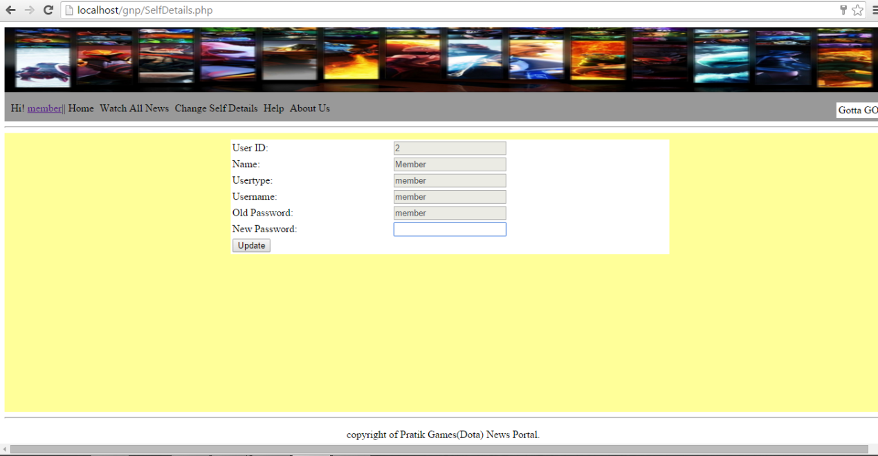

Figure 12: Manage User Page

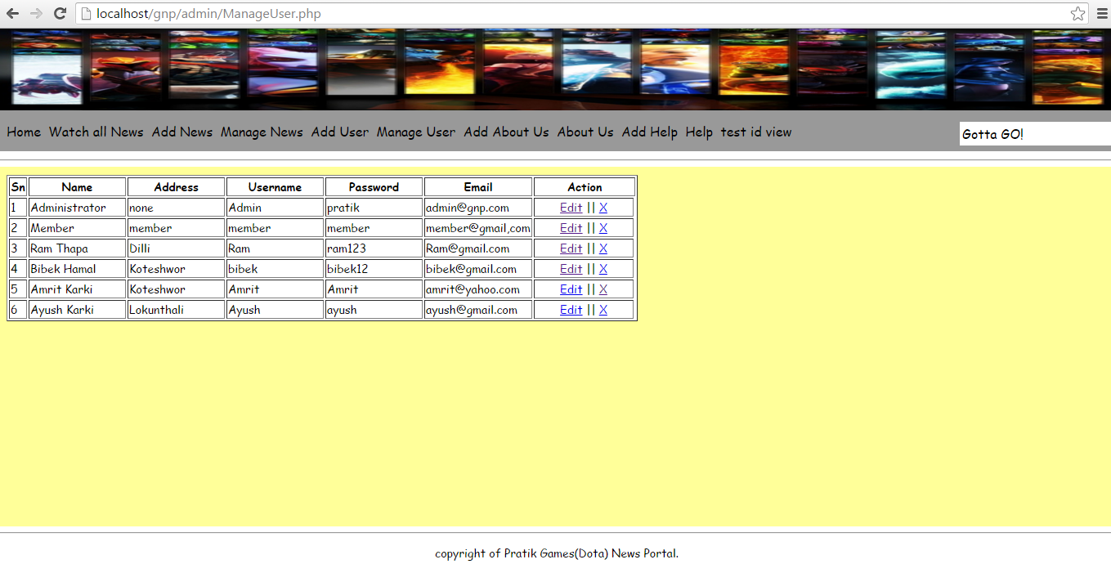

Figure 13: About Us Page

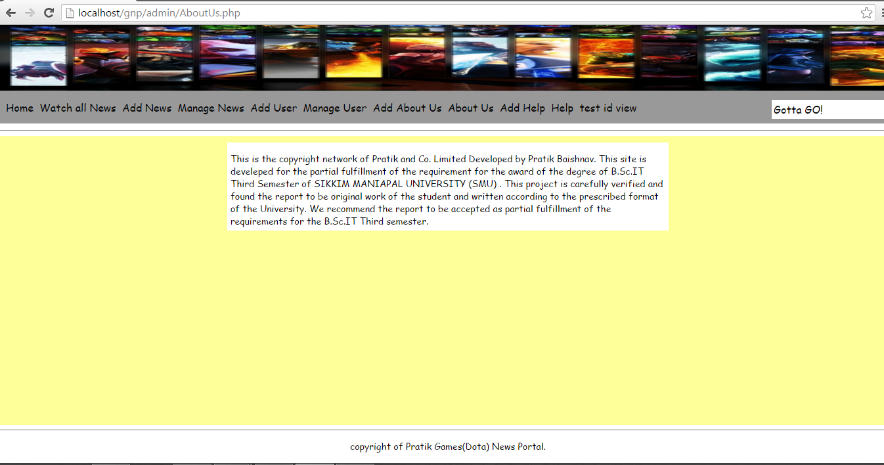

**10.2 SOURCE CODE**

* **Login**

<table align="center">

<tr align="center"><td><h2>Login</h2><hr></td></tr>

<form method="post" action="index.php?page=Login">

<tr><td><br>

<b><font color="#008000">&nbsp;Username&nbsp;&nbsp;&nbsp;:

<input type="text" name="username" autofocus required/><br/><br/>

&nbsp;Password&nbsp;&nbsp;&nbsp; :</font>

<input type="password" name="password" required/><br /><br />

<font color="#A40000">&nbsp;Login Type&nbsp;&nbsp;:

<select name="usertype" >

<option value="0">[choose]</option>

<option>member</option>

<option>user</option></select>

</td></tr>

<tr><td bgcolor="#EEEEEE">

<left><input type="checkbox" name = "remember-me" value="remember-me" checked/> Keep me signed in </left>

&nbsp;&nbsp;&nbsp;&nbsp;&nbsp;&nbsp;&nbsp;&nbsp;&nbsp;&nbsp;&nbsp;&nbsp;&nbsp;&nbsp;&nbsp;&nbsp;&nbsp;&nbsp;&nbsp;&nbsp;&nbsp;&nbsp;&nbsp;&nbsp;&nbsp;&nbsp;&nbsp;&nbsp;&nbsp;&nbsp;&nbsp;&nbsp;&nbsp;&nbsp;&nbsp;&nbsp;&nbsp;&nbsp;&nbsp;&nbsp;

<input type="submit" value="Login" name="submit"></b>

</td></tr>

</form>

<tr><td align="center"><hr><a href="index.php?page=SignUp" ><font size="1px" face="Georgia, Times New Roman, Times, serif" color="#008000">*Not registered yet? <b><font color="#0000A8" size="1">&nbsp;JOIN US now!&nbsp;</font></font></b></a></p>

</td></tr> </table>

<?php

error_reporting(0);

session_start();

if (isset($_SESSION['userid'])){

header('location:index.php');

if ($_SESSION['type']=='user'){

header('location:admin/index.php');

}

else if ($_SESSION['type']=='member'){

header('location:index.php');

}

}

include 'admin/includes/config.php';

//include 'userincludes/userconfig.php';

?>

<?php

if(isset($_POST['submit']))

{

$username = $_POST['username'];

$password = $_POST['password'];

$usertype = $_POST['usertype'];

if ($usertype == "user")

{

$t="user";

$sql = "SELECT * FROM table_users WHERE Username='".$username."' AND Password = '".$password."' AND Usertype='".$t."'";

$res = mysql_query($sql) or trigger_error("There was some error in the sql statement" . mysql_error());

$row = mysql_fetch_array($res);

if ($username = $row['Username'] && ($usertype = $row['Usertype'] && $password = $row['Password'] ))

{

if(is_array($row))

{

$psd=$_SESSION["pswd"]=$row['Password']; //creating session

$usid=$_SESSION["userid"] = $row['UserID'];

$unam=$_SESSION["username"] = $row['Username'];

$uty=$_SESSION["type"] = $row['Usertype'];

}

if (isset($_POST["remember-me"])){

setcookie('uid', $usid, time()+60*60*24*2);

setcookie('uname', $unam, time()+60*60*24*2);

setcookie('psswd', $psd, time()+60*60*24*2);

setcookie('utype', $uty, time()+60*60*24*2);

}

else{

setcookie('uid', "");

setcookie('uname', "");

setcookie('psswd', "");

setcookie('utype', "");

}

//directing to admin homepage

if(isset($_SESSION["userid"]))

{

//include 'includes/logentry.php';

header("location:admin/index.php");

exit;

}

else{

echo '&nbsp;&nbsp;&nbsp;&nbsp;&nbsp;<font color="maroon">Session not set</font>';

}

}

echo '&nbsp;&nbsp;&nbsp;&nbsp;&nbsp;<font color="white" ><center>Please type your login credentials.</center></font>';

}

if($usertype == "member")

{

$q="member";

$sql="SELECT * FROM table_users WHERE Username='".$username."' AND (Password='".$password."' AND Usertype='".$q."')";

$result=mysql_query($sql) or trigger_error("There was some error in the sql statement" . mysql_error());

$row = mysql_fetch_array($result);

if ($username = $row['Username'] && ($usertype = $row['Usertype'] && $password = $row['Password'] )){

if(is_array($row))

{

$psd=$_SESSION["pswd"]=$row['Password'];

$usid=$_SESSION["userid"] = $row['UserID'];

$unam=$_SESSION["username"] = $row['Username'];

$uty=$_SESSION["type"] = $row['Usertype'];

}

if (isset($_POST["remember-me"])){

setcookie('uid', $usid, time()+60*60*24*2);

setcookie('uname', $unam, time()+60*60*24*2);

setcookie('psswd', $psd, time()+60*60*24*2);

setcookie('utype', $uty, time()+60*60*24*2);

}

else{

setcookie('uid', "");

setcookie('uname', "");

setcookie('psswd', "");

setcookie('utype', "");

}

//directing to admin homepage

if(isset($_SESSION["userid"]))

{

//include 'includes/logentry.php';

header("location:index.php");

exit;

}

else{

echo '&nbsp;&nbsp;&nbsp;&nbsp;&nbsp;<font color="maroon">Session not set</font>';

}

}

echo '&nbsp;&nbsp;&nbsp;&nbsp;&nbsp;<font color="white" ><center>Please type your login credentials.</center></font>';

}

}

?>

<?php

if(isset($_GET['action']) && $_GET['action'] == "forget"){

setcookie('uid', "");

setcookie('uname', "");

setcookie('psswd', "");

setcookie('utype', "");

header('location:index.php');

}

?>

* **Basic Main Page**

<?php

error_reporting(0);

include 'userincludes/userconfig.php';

//$type=$_SESSION['type'];

echo '<table>';

echo '<tr>';

$j = 1;

$query = "SELECT * FROM table_news ORDER BY NewsID DESC";

$sql = mysql_query($query);

$affrows = mysql_affected_rows($conn);

if($affrows > 0){

//echo'Latest entries';

for($i = 1; $rows= mysql_fetch_assoc($sql); $i++) {

if($i<4){

$id = $rows["NewsID"];

$title = $rows["Title"];

$img = $rows["ImageName"];

$cat = $rows["Category"];

$cd = $rows["CreatedDate"];

$des = $rows["Description"];

echo '<td width="100px">

<td><img src="admin/includes/img/'.$img.'" height="120px" width="200px"></td>';

echo '<td width="100px">

<td width="300px" height="120px">

<b>NewsID: </b>'?><?php echo $id; ?><?php echo '<br />

<b>Title: </b>'?><?php echo $title; ?><?php echo '<br />

<b>Category: </b>'?><?php echo $cat; ?><?php echo '<br />

<b>Added In: </b>'?><?php echo $cd; ?><?php echo '<br />

<td width="300px" align="right">

'?> <textarea maxlength="50" rows="6" cols="100" disabled><?php echo $des;?></textarea>

<?php echo '<table border="0" bgcolor="#33CCCC"><tr><td>

<a href="'?><?php echo 'ViewNews.php?&id='.$id;

echo'"><b>Read More</b></a><br />

</td>

</td></tr>

</table>

</td>

<td width="20">

</td>';

if ($i == $j){

echo'</tr>';

echo'<tr>';

$j = $j +1;

}

}

else {}

}

echo '</tr>';

echo '</table>';

}else{

echo"You have no files to display.";

}

?>

<table align="center" width="50%">

<tr><hr></tr>

<tr align="center"> <td> <a href="index.php?page=Login">Join Us! </a>For more news and full access.</td></tr></table>

</div>

* **Admin CSS Style**

/* CSS Document */

body{

margin:0;

padding:0;

width:100%;

font:14px "Comic Sans MS","Times New Roman", Times, serif, Verdana, Arial, san-serif;

}

.container

{

margin: auto;

width: auto;

overflow:;

}

/*for header*/

header{

width:auto;

height:20%;

overflow:hidden;

}

nav{

height:40px;

width:100%;

overflow:hidden;

background-color:#CCC;

margin:0px 0px 10px;

padding-left:10px;

padding-bottom:10px;

}

.navigation ul{

padding: 0px;

margin-bottom: 11px;

border-right:1px #900;

}

.navigation ul li{

list-style:none;

display:inline;

margin-right:5px;

}

.navigation ul li a{

background-color:;

text-decoration:none;

color:#000;

font-size:16px;

}

.navigation ul a:hover{

border-bottom: 2px solid #FF0000;

}

/*for footer*/

footer{

clear:both;

width:inherit;

height:10%;

}

footer p{

text-align:center;

}

/*for main content*/

.content{

width:98.5%;

background-color: #0C6;

height:420px;

padding:10px;

overflow:auto;

}

table{

background: white;

font-color:white;

}

/*for editting*/

.editting {

float:right;

overflow:auto;

}

.viewing {

float:left;

height: 400px;

overflow:auto;

align:center;

}

.sitename

{

text-align:center;

height: auto;

overflow:auto;

}

* **Config Page**

<?php

define('HOST', 'localhost');

define('USER', 'root');

define('PWD', '');

define('DB', 'gnp');

//connect to the server

$conn = mysql_connect(HOST, USER, PWD) or trigger_error("Connection error" . mysql_error());

//load the database

@mysql_select_db(DB) or trigger_error("Database not found" . mysql_error());

/*

for checking conncection remove comment and try.

if($conn)

{

echo"Great work";

}

else

{

echo "connection error";

}

die();

*/

?>

* **Footer Page**

<footer>

<hr>

<p>copyright of Pratik Games(Dota) News Portal.</p>

</footer>

* **Admin Header Page**

<header>

<img src="includes/img/Xtras/cha.jpg" width="100%" height="100px">

<div class="sitename"> </div>

<nav class="navigation">

<ul>

<!--example <a href="DisplayNews.php"> Linking after clicking or manual linking-->

<li><a href="index.php">Home</a>

<li><a href="DisplayNews.php">Watch all News</a></li>

<li><a href="index.php?page=AddNews">Add News</a></li>

<li><a href="ManageNews.php">Manage News</a></li>

<li><a href="index.php?page=AddUser">Add User</a></li>

<li><a href="ManageUser.php">Manage User</a></li>

<li><a href="index.php?page=AddImages">Add Images</a></li>

<li><a href="ViewGallery.php">Gallery</a></li>

<li><table align="right" width="200"> <tr> <td><a href="includes/LogOut.php">Gotta GO!</a></td></tr></table></li>

</ul>

</nav>

<hr>

</header>

* **Logout Page**

<?php

session_start();

//$lin = $_SESSION['lindate'];

include 'config.php';

/*//date_default_timezone_set('Asia/Kathmandu');

//$lout = date('Y-m-d H:i:s');

$sql = "UPDATE tbl_logentry SET LoggedOut='".$lout."' WHERE LoggedIn='".$lin."'";

$result=mysql_query($sql) or trigger_error("There was some error in the sql statement" . mysql_error());

if($result==FALSE) { die(mysql_error()); }*/

if(isset($_COOKIE['uid'])){

/*setcookie('uid', "");

setcookie('uname', "");

setcookie('psswd', "");

setcookie('utype', "");*/

setcookie('uid',$_SESSION['userid'], time() - (3600));

setcookie("uname",$_SESSION["username"], time() - (3600)); // 86400=1din 60sec 60min 24hr

setcookie("utype",$_SESSION["type"],time() - (3600));

setcookie("psswd",$_SESSION["pswd"],time()-(3600));

}

session_destroy();

$_SESSION['userid'] = "";

$_SESSION['username'] = "";

$_SESSION['type'] = "";

$_SESSION['lindate'] = "";

$_SESSION['logid'] = "";

header("Location: ../../../gnp/index.php");

?>

* **Add Images Page**

<form method="post" action="index.php?page=AddImages" enctype="multipart/form-data">

<table align="center" border="0" width="50%" cellspacing="0" cellpadding="5" >

<tr>

<td><label>Title:</label></td>

<td ><input type="text" name="Title" autofocus="autofocus" required/></td>

</tr>

<tr>

<td><label>File:</label> </td>

<td><input type="file" name="imagefile"/></td>

</tr>

<tr align="left">

<td colspan="2"><input type="submit" name="submit" value="Upload this" /></td>

</tr>

</table>

</form>

<?php

include'includes/config.php';

error_reporting(0);

if(isset($_POST['submit']))

{

$title = $_POST['Title'];

//taking image file and storing

$image= addslashes(file_get_contents($_FILES['imagefile']['tmp_name']));

$name= $_FILES['imagefile']['name'];

$tmp_name=$_FILES['imagefile']['tmp_name'];

date_default_timezone_set('Asia/Kathmandu');

$date =date('Y-m-d H:i:s');

//$size=filesize($tmp_name);

//if( $size < 1000000000) //almost 2MB(image size limitation)

//{

if(isset ($name) )

{

if (!empty($name))

{

$location="includes/img/Wallpapers/";

if(move_uploaded_file($tmp_name, $location.$name))

{

$query="INSERT INTO table_gallery(Title, AddedDate, ImageName) VALUES('".$title."','".$date."','".$name."')";

$result = mysql_query($query) or trigger_error("There was some error in the sql statement" . mysql_error());

$affrows = mysql_affected_rows($conn);

if($affrows > 0)

{

//header('location:index.php');

echo '<center><font color="white"><b>Report entry successful. Thank you.</b></font></center>';

}

else {echo 'Report is NOT added to database';}

}

else {echo "Error in moving file to database. Please re-try ";}

}

else {echo "You must upload an image.";}

}

//}

//else {echo "Size limit violated";}

}

?>

* **Add News Page**

<form method="post" action="index.php?page=AddNews" enctype="multipart/form-data">

<table align="center" border="0" width="50%" cellspacing="0" cellpadding="5" >

<!--table: making a boundary for table, tr: creates a row within a table, td: creates a data field within a row -->

<tr>

<td><label>Title:</label></td>

<td ><input type="text" name="TitleBox" autofocus="autofocus" required/></td>

</tr>

<tr>

<td><label>Category:</label> </td>

<td><select name="CategoryBox">

<option value="0">[choose]</option>

<option>Nuker </option>

<option>Support</option>

<option>Tank</option>

<option>Carry</option>

</select></td>

</tr>

<tr>

<td><label>Image:</label> </td>

<td><input type="file" name="imagefile"/></td>

</tr>

<!--<tr><td></td><td><p> (*Image size must be less than 1MB)</p></td></tr>-->

<tr>

<td><label>Description:</label></td>

<td><textarea type="text" name="DescriptionBox" cols="100" rows="15" required="required"></textarea></td>

</tr>

<tr align="left">

<td colspan="2"><input type="submit" name="submit" value="Add this" /></td>

</tr>

</table>

</form>

<?php

include'includes/config.php';

error_reporting(0);

?>

<?php

//posting data into variables below (defining variables)

$title = $_POST['TitleBox'];

$category = $_POST['CategoryBox'];

$createdby = 'admin';

//for date

date_default_timezone_set('Asia/Kathmandu');

$createddate =date('Y-m-d H:i:s');

$modifiedby='null';

$modifieddate='null';

$description = $_POST ['DescriptionBox'];

//checking validation/requests/inserting into database.

if(isset($_POST['submit']))

{

//taking image file and storing

$image= addslashes(file_get_contents($_FILES['imagefile']['tmp_name']));

$name= $_FILES['imagefile']['name'];

$tmp_name=$_FILES['imagefile']['tmp_name'];

$size=filesize($tmp_name);

if (strlen($description)<999999999)//limiting text size for description.

{

if( $size < 100000000) //almost 1MB(image size limitation)

{

if(isset ($name) AND $category!="0")

{

if (!empty($name))

{

$location="includes/img/";

if(move_uploaded_file($tmp_name, $location.$name))

{

$query="INSERT INTO table_news(Title, Category, Description, CreatedBy,CreatedDate, ModifiedBy, ModifiedDate, ImageName) VALUES('".$title."','".$category."','".$description."', '".$createdby."', '".$createddate."','".$modifiedby."','".$modifieddate."','".$name."')";

$result = mysql_query($query) or trigger_error("There was some error in the sql statement" . mysql_error());

$affrows = mysql_affected_rows($conn);

if($affrows > 0)

{

//header('location:index.php');

echo '<center><font color="white"><b>Report entry successful. Thank you.</b></font></center>';

}

else {echo 'Report is NOT added to database';}

}

else {echo "Error in moving file to database. Please re-try ";}

}

else {echo "You must upload an image.";}

}

else

{

echo '<center><font color="maroon"><b>Please re-define your category.. </b></font></center>';

}

}

else {echo '<center><font color="maroon"><b>Error in uploading image.. Make sure your image is less than 1MB. </b></font></center>';}

}

else {

echo '<center><font color="maroon"><b>Please make your description no more than 1000 characters.</b></font></center>';}

//echo "Current word count:&nbsp;".str_word_count($description);

//echo "Current character length:&nbsp;".strlen($description);

}

?>

* **Add User Page**

<form method="post" action="index.php?page=AddUser" enctype="multipart/form-data">

<!--Design Part-->

<table align="center" border="0" width="50%" cellspacing="0" cellpadding="5" >

<tr>

<td><label>Name:</label></td>

<td><input type="text" name="NameBox" autofocus="autofocus" required/></td>

</tr>

<tr>

<td><label>Address:</label></td>

<td><input type="text" name="AddressBox" /></td>

</tr>

<tr>

<td><label>Username:</label></td>

<td><input type="text" name="UsernameBox" /></td>

</tr>

<tr>

<td><label>Password:</label></td>

<td><input type="password" name="PasswordBox" /></td>

</tr>

<tr>

<td><label>E-mail:</label></td>

<td><input type="text" name="EmailBox" /></td>

</tr>

<tr align="center">

<td colspan="2"><input type="submit" name="submit" value="Add this" /></td>

</tr>

</table>

</form>

<!--Connection/Defining variables/SQL Part -->

<?php

include 'includes/config.php';

error_reporting(0);

?>

<?php

//Definigh Variables

if(isset ($_POST['submit'])){

$name= $_POST['NameBox'];

$address= $_POST['AddressBox'];

$username= $_POST['UsernameBox'];

$password= $_POST['PasswordBox'];

$email= $_POST['EmailBox'];

$utype='member';

//SQL Query

$query="insert into table_users(Name, Address, Username, Password, Email,Usertype) values('".$name."', '".$address."', '".$username."' , '".$password."', '".$email."', '".$utype."')";

$result = mysql_query($query) or trigger_error("There was some error in the sql statement" . mysql_error());

$affrows = mysql_affected_rows($conn);

if($affrows > 0)

{

//header('location:index.php');

echo '<center><font color="white"><b>Report entry successful. Thank you.</b></font></center>';

}

else {echo 'Report is NOT added to database';}

}

?>

* **All News Page**

<table width = "100%" align="justify"><tr>

<tr align="center">

<td><font size="6.2px" >Search Bar</font></td>

<td width="50%">

<form action="DisplayNews.php">

<label><b>Category:</b></label>

<select name="category" >

<option>Tank</option>

<option>Support</option>

<option>Carry</option>

<option>Nuker</option>

</select>

</td>

<td align="left"><input name="search" type="text" placeholder="Field Data"/>

<input type="submit" value = "Search"/>&nbsp;&nbsp;&nbsp;</td>

<td align="right">

|<a href="DisplayNews.php">Refresh</a>|</td>

</form>

</tr></table>

<?php

include 'includes/config.php';

//search

if(isset($_GET["search"])) {

$s = $_GET["search"];

$category= $_GET["category"];

$qry = "SELECT * FROM table_news ";

$qry.= " WHERE (Title like '%".$s."%' ) AND (Category like '".$category."') "; //to show all AND->OR.

}

else {

$qry = "SELECT * FROM table_news ORDER BY NewsID DESC";

//$query = "SELECT * FROM table_news ";

}

$sql = mysql_query($qry);

$affrows = mysql_affected_rows($conn);

$bgcolor='#FFFFFC';

echo '<table>';

echo '<tr>';

$j = 1;

if($affrows > 0){

for($i = 1; $rows= mysql_fetch_assoc($sql); $i++)

{

$id = $rows["NewsID"];

$title = $rows["Title"];

$img = $rows["ImageName"];

$cat = $rows["Category"];

$cd = $rows["CreatedDate"];

$des = $rows["Description"];

echo '<td width="100px">

<td><img src="includes/img/'.$img.'" height="120px" width="200px"></td>';

echo '<td width="100px">

<td width="300px" height="120px">

<b>NewsID: </b>'?><?php echo $id; ?><?php echo '<br />

<b>Title: </b>'?><?php echo $title; ?><?php echo '<br />

<b>Category: </b>'?><?php echo $cat; ?><?php echo '<br />

<b>Added In: </b>'?><?php echo $cd; ?><?php echo '<br />

<td width="300px" align="right">

'?> <textarea maxlength="50" rows="6" cols="100" disabled><?php echo $des;?></textarea>

<?php echo '<table border="0" bgcolor="#33CCCC"><tr><td>

<a href="'?><?php echo 'ViewNews.php?&id='.$id;

echo'"><b>Read More</b> </a><br />

</td>

</td></tr>

</table>

</td>

<td width="20">

</td>';

if ($i == $j){

echo'</tr>';

echo'<tr>';

$j = $j +1;

}

}

echo '</tr>';

echo '<hr /></table>';

}else{

echo"You have no files to display.";

}

?>

* **Display News Page**

<?php

error_reporting(0);

session_start();

$message="";

if (isset ($_SESSION["type"])){

$ustype=$_SESSION["type"];

if ($ustype=="member"){

header("location:../../../gnp/index.php");

}

}

if(!isset($_SESSION['userid'])){

header("location:../../../gnp/index.php");

}

?>

<?php

//error_reporting(0);

?>

<!DOCTYPE html PUBLIC "-//W3C//DTD XHTML 1.0 Transitional//EN" "http://www.w3.org/TR/xhtml1/DTD/xhtml1-transitional.dtd">

<html xmlns="http://www.w3.org/1999/xhtml">

<head>

<meta http-equiv="Content-Type" content="text/html; charset=utf-8" />

<title>Display All News</title>

<link rel="stylesheet" type="text/css" href="includes/AdminStyle.css" />

<style>

textarea {overflow:hidden} </style>

</head>

<body>

<div class="container">

<?php include'includes/header.php';?>

<div class="content">

<?php

if(!isset($_GET['page']))

{

include 'AllNews.php';

}

else

{

if(isset($_GET['page']))

{

$page = $_GET["page"];

$filename = include("".$page.'.php');

if($filename == "")

{

header("location:DisplayNews.php");

}

if(file_exists($filename)){

include $filename;

}

}

}

?>

</div>

</div>

<?php include'includes/footer.php'; ?>

</body>

</html>

* **Edit News Page**

<?php

error_reporting(0);

session_start();

$message="";

if (isset ($_SESSION["type"])){

$ustype=$_SESSION["type"];

if ($ustype=="member"){

header("location:../../../gnp/index.php");

}

}

if(!isset($_SESSION['userid'])){

header("location:../../../gnp/index.php");

}

?>

<?php

error_reporting(0);

?>

<!DOCTYPE html PUBLIC "-//W3C//DTD XHTML 1.0 Transitional//EN" "http://www.w3.org/TR/xhtml1/DTD/xhtml1-transitional.dtd">

<html xmlns="http://www.w3.org/1999/xhtml">

<head>

<meta http-equiv="Content-Type" content="text/html; charset=utf-8" />

<title>Admin Games News Portal</title>

<link rel="stylesheet" type="text/css" href="includes/AdminStyle.css" />

</head>

<body>

<div class="container">

<?php include'includes/header.php'?>

<div class="content">

<?php include 'includes/config.php'?>

<?php

//retriving data

if(isset($_GET['id']))

{

$id = $_GET['id'];

}

$query1="SELECT * FROM table_news where NewsID =".$id;

$result1=mysql_query($query1) or trigger_error("There was some error in the sql statement" . mysql_error());

$row = mysql_fetch_array($result1);

//Defining variablies and showing in different steps(mthod2)

if(is_array($row))

{

$title = $row ['Title'];

$category = $row ['Category'];

$description = $row['Description'];

$imagefile = $row['ImageName'];

$createdby = $row['CreatedBy'];

}

?>

<form method="post" action="EditNews.php" enctype="multipart/form-data">

<input type="hidden" name="id" value="<?php echo $id; ?>" />

<table width='50%' align="center">

<tr>

<td><label>Title:</label></td>

<td ><input type="text" name="Title" value="<?php echo $title; ?>" disabled="disabled"/></td>

</tr>

<tr>

<td><label>Category:</label> </td>

<td><input type="text" name="Category" value="<?php echo $category; ?>" disabled="disabled"/></td>

</tr>

<tr>

<td><label>Image:</label> </td>

<td><?php echo $imagefile; ?></td>

</tr>

<!--<tr><td></td><td><p> (*Image size must be less than 1MB)</p></td></tr>-->

<tr>

<td><label>Description:</label></td>

<td><textarea type="text" name="Description" cols="35" rows="5" autofocus required="required"><?php echo $description;?></textarea></td></tr>

<tr>

<td colspan="2"><input type="submit" name="Update" value="Update" /></td>

</tr>

</table>

</form>

<?php

//updating data

if(isset($_POST['Update'])&& $_POST['Update'] == "Update")

{

$id = $_POST['id'];

date_default_timezone_set('Asia/Kathmandu');

$md = date ('Y-m-d H:i:s');

$mby = 'Admin';

$des = $_POST['Description'];

$query = "UPDATE table_news SET ModifiedDate='".$md."', ModifiedBy='".$mby."', Description='".$des."' WHERE NewsID=".$id;

$result = mysql_query($query) or trigger_error("There was some error in the sql statement" . mysql_error());

$affrows = mysql_affected_rows($conn);

if($affrows > 0)

{

echo'<center><font color="grey"><b>News updated successfully. </b></font></center>';

}

else{ echo'<center><font color="maroon"><b>News update Failed. Please re-try</b></font></center>'; }

}

?>

</div>

</div>

<?php include'includes/footer.php' ?>

</div>

</body>

</html>

* **Manage News Page**

<?php

error_reporting(0);

session_start();

$message="";

if (isset ($_SESSION["type"])){

$ustype=$_SESSION["type"];

if ($ustype=="member"){

header("location:../../../gnp/index.php");

}

}

if(!isset($_SESSION['userid'])){

header("location:../../../gnp/index.php");

}

?>

<!DOCTYPE html PUBLIC "-//W3C//DTD XHTML 1.0 Transitional//EN" "http://www.w3.org/TR/xhtml1/DTD/xhtml1-transitional.dtd">

<html xmlns="http://www.w3.org/1999/xhtml">

<head>

<meta http-equiv="Content-Type" content="text/html; charset=utf-8" />

<title>Admin Games News Portal</title>

<link rel="stylesheet" type="text/css" href="includes/AdminStyle.css" />

</head>

<body>

<div class="container">

<?php include'includes/header.php'?>

<div class="content">

<div class="viewing">

<table border="1" >

<tr >

<td align="center"><strong>Sn</strong></td>

<td style="width:115px" align="center"><strong>Title</strong></td>

<td style="width:115px" align="center"><strong>Category</strong></td>

<td align="center"><strong>Added By</strong></td>

<td style="width:115px"align="center"><strong>Added Date</strong></td>

<td style="width:115px"align="center"><strong>Modified Date</strong></td>

<td style="width:115px" align="center"><strong>Modified By</strong></td>

<td colspan="2" style="width:120px" align="center"><strong>Action</strong></td>

</tr>

<?php

include 'includes/config.php';

$sql="select * from table_news";

$rel=mysql_query($sql);

$sn=0;

while($row=mysql_fetch_array($rel))

{ ?>

<!--Defining variablies and showing in same steps -->

<tr>

<td><?php echo $sn=$sn+1; ?></td>

<td style="width:115px"><?php echo $title=$row ['Title']; ?></td>

<td style="width:115px"><?php echo $category=$row['Category']; ?></td>

<td style="width:115px"><?php echo $createdby=$row['CreatedBy']; ?></td>

<td style="width:115px"><?php echo $createddate=$row['CreatedDate']; ?></td>

<td style="width:115px"><?php echo $modifieddate=$row['ModifiedDate']; ?></td>

<td style="width:115px"><?php echo $modifiedby=$row['ModifiedBy']; ?></td>

<td align="center">

<a href="<?php echo 'EditNews.php?&id='.$row["NewsID"];?>">Edit</a> ||

<a href="<?php echo 'ManageNews.php?action=delete&id='.$row["NewsID"];?>" onclick="return confirm('Are you sure?')">X</a>

<?php

// Deleting Item

if(isset($_GET['action']) && $_GET['action'] == "delete")

{

$id = $_GET['id'];

mysql_query("DELETE FROM table_news WHERE NewsID=".$id);

//linking bak to page(automatic linkin)

header("Location: ManageNews.php");

}

?>

</td></tr>

<?php } ?>

</table>

</div>

</div>

<?php include'includes/footer.php' ?>

</div>

</body>

</html>

* **Manage User Page**

<?php

error_reporting(0);

session_start();

$message="";

if (isset ($_SESSION["type"])){

$ustype=$_SESSION["type"];

if ($ustype=="member"){

header("location:../../../gnp/index.php");

}

}

if(!isset($_SESSION['userid'])){

header("location:../../../gnp/index.php");

}

?>

<!DOCTYPE html PUBLIC "-//W3C//DTD XHTML 1.0 Transitional//EN" "http://www.w3.org/TR/xhtml1/DTD/xhtml1-transitional.dtd">

<html xmlns="http://www.w3.org/1999/xhtml">

<head>

<meta http-equiv="Content-Type" content="text/html; charset=utf-8" />

<title>Admin Games News Portal</title>

<link rel="stylesheet" type="text/css" href="includes/AdminStyle.css" />

</head>

<body>

<div class="container">

<?php include'includes/header.php'?>

<div class="content">

<div class="viewing">

<table border="1" >

<tr >

<td align="center"><strong>Sn</strong></td>

<td style="width:115px" align="center"><strong>Name</strong></td>

<td style="width:115px" align="center"><strong>Address</strong></td>

<td align="center"><strong>Username</strong></td>

<td style="width:115px"align="center"><strong>Password</strong></td>

<td style="width:115px"align="center"><strong>Email</strong></td>

<td colspan="2" style="width:120px" align="center"><strong>Action</strong></td>

</tr>

<!--Connection with database-->

<?php

include 'includes/config.php';

$sql="select * from table_users";

$rel=mysql_query($sql);

$sn=0;

while($row=mysql_fetch_array($rel))

{

?>

<!--Defining variablies and showing in same steps -->

<tr>

<td><?php echo $sn=$sn+1 ?></td>

<td style="width:115px"><?php echo $name=$row['Name']; ?> </td>

<td style="width:115px"><?php echo $address=$row['Address']; ?> </td>

<td style="width:115px"><?php echo $username=$row['Username']; ?> </td>

<td style="width:115px"><?php echo $password=$row['Password']; ?> </td>

<td style="width:115px"><?php echo $email=$row['Email']; ?> </td>

<td align="center">

<a href="<?php echo 'EditUser.php?&id='.$row["UserID"];?>">Edit</a> ||

<a href="<?php echo 'ManageUser.php?action=delete&id='.$row["UserID"];?>" onclick="return confirm('Are you sure?')">X</a>

<?php

//deleting

if(isset($_GET['action']) && $_GET['action'] == "delete")

{

$id= $_GET['id'];

mysql_query("DELETE FROM table_users WHERE UserID=".$id);

//linking bak to page

header("Location: ManageUser.php");

}

?>

</td>

</tr>

<?php } ?>

</table>

</div>

</div>

<?php include'includes/footer.php' ?>

</div>

</body>

</html>

* **View Gallery Page**

<?php

error_reporting(0);

session_start();

$message="";

if (isset ($_SESSION["type"])){

$ustype=$_SESSION["type"];

if ($ustype=="member"){

header("location:../../../gnp/index.php");

}

}

if(!isset($_SESSION['userid'])){

header("location:../../../gnp/index.php");

}

?>

<?php

error_reporting(0);

?>

<!DOCTYPE html PUBLIC "-//W3C//DTD XHTML 1.0 Transitional//EN" "http://www.w3.org/TR/xhtml1/DTD/xhtml1-transitional.dtd">

<html xmlns="http://www.w3.org/1999/xhtml">

<head>

<meta http-equiv="Content-Type" content="text/html; charset=utf-8" />

<title>Display All News</title>

<link rel="stylesheet" type="text/css" href="includes/AdminStyle.css" />

</head>

<body>

<div class="container">

<?php include'includes/header.php';?>

<div class="content">

<?php

include 'includes/config.php';

$qry = "SELECT * FROM table_gallery ORDER BY GalleryID DESC";

$sql = mysql_query($qry);

$affrows = mysql_affected_rows($sql);

echo '<table>';

echo '<tr>';

$j = 4;

if($affrows > 0){

for($i = 1; $rows= mysql_fetch_assoc($sql); $i++)

{

$id = $rows["GalleryID"];

$title = $rows["Title"];

$img = $rows["ImageName"];

$ad = $rows["AddedDate"];

echo '<td><a href="includes/img/Wallpapers/'.$img.'" ><img src="includes/img/Wallpapers/'.$img.'" height="270px" width="325px" alt="'.$title.'" title="'.$title.'" "></a></td>';

if ($i == $j){

echo'</tr>';

echo'<tr>';

$j = $j +4;

}

}

echo '</tr>';

echo '<hr /></table>';

}else{

echo"You have no files to display.";

}

?>

</div>

</div>

<?php include'includes/footer.php'; ?>

</body>

</html>

* **View News Page**

<?php

error_reporting(0);

session_start();

$message="";

if (isset ($_SESSION["type"])){

$ustype=$_SESSION["type"];

if ($ustype=="member"){

header("location:../../../gnp/index.php");

}

}

if(!isset($_SESSION['userid'])){

header("location:../../../gnp/index.php");

}

?>

<!DOCTYPE html PUBLIC "-//W3C//DTD XHTML 1.0 Transitional//EN" "http://www.w3.org/TR/xhtml1/DTD/xhtml1-transitional.dtd">

<html xmlns="http://www.w3.org/1999/xhtml">

<head>

<meta http-equiv="Content-Type" content="text/html; charset=utf-8" />

<title>News Description</title>

<link rel="stylesheet" type="text/css" href="includes/AdminStyle.css" />

</head>

<body>

<div class="container">

<?php include'includes/header.php';?>

<div class="content">

<?php

error_reporting(0);

include 'includes/config.php';

//retriving data

if(isset($_GET['id'])){

$id = $_GET['id'];

}

$sql="SELECT * FROM table_news WHERE NewsID =".$id;

$result1=mysql_query($sql) or trigger_error("There was some error in the sql statement" . mysql_error());

$row = mysql_fetch_array($result1);

if(is_array($row)) {

$newsid = $row["NewsID"];

$title = $row["Title"];

$img = $row["ImageName"];

$cat = $row["Category"];

$cd = $row["CreatedDate"];

$des = $row["Description"];

$uname = $row["CreatedBy"];

$modify = $row["ModifiedDate"];

}

?>

<table width="100%">

<tr>

<td align="left" width="400px"><?php echo '<img src="includes/img/'.$img.'" height="280px" width="350px">';?></td>

<td align ="left" height="280px" width="550px"><font color="#424242">

<b>News ID: </b> <?php echo '<font color="#AE4F09">'.$id.'</font>'; ?><br />

<b>Title Name: </b> <?php echo '<font color="#AE4F09"><b>'.$title.'</b></font>'; ?><br />

<b>Image Name:</b><?php echo '<font color="#AE4F09">'.$img.'</font>'; ?><br />

<b>Category:</b><?php echo '<font color="#AE4F09"><b>'.$cat.'</b></font>'; ?><br /><hr />

<b>Added In:</b><?php echo '<font color="#AE4F09">'.$cd.'</font>'; ?><br />

<b>Added By:</b><?php echo '<font color="#AE4F09">'.$uname.'</font>'; ?><br />

<b>Updated In:</b><?php echo '<font color="#AE4F09">'.$modify.'</font>'; ?><br /><hr />

</td></tr>

</table>

<hr color="#FFFFFF"/>

<table width="75%" align="center"> <tr align=""><td width ="" height="200" align="center">

<b>Description<br /></b><?php echo '<font color="#AE4F09">'.$des.'</font>'; ?><br /></font>

</td></tr></table>

</div>

</div>

<?php include'includes/footer.php'; ?>

</body>

</html>

* **Member Header Page**

<header>

<img src="admin/includes/img/Xtras/cha.jpg" width="100%" height="100px">

<nav class="navigation">

<ul>

Hi! <a href="index.php?page="EditMyProfile"><?php echo $_SESSION['username'];?></a>||

<li><a href="index.php">Home</a></li>

<li><a href="DisplayNews">Watch All News</a></li>

<li><a href="SelfDetails.php">Change Self Details</a></li>

<li><a href="ImageGallery.php">Image Gallery</a></li>

<li><a href="Help.php">Help </a></li>

<li><a href="AboutUs.php">About Us</a></li>

<li><table align="right" width="80"> <tr> <td><a href="userincludes/LogOut.php">Gotta GO!</a></td></tr></table></li>

</ul>

</nav>

<hr>

</header>

* **Visitor Header Page**

<header>

<img src="admin/includes/img/Xtras/cha.jpg" width="100%" height="100px">

<nav class="navigation">

<ul>

<li><a href="index.php">Latest News</a></li>

<li><a href="AboutUs.php">About Us</a></li>

<li><table align="right" width="80"><tr align="left">

<td>

<a href="index.php?page=Login">Login </a>

</td>

</tr>

</table>

</li>

</ul>

</nav>

<hr>

</header>

## 11. USER OPERATIONS AND MANUAL

User operational manual includes the handling of my project on various regards. Some of them are as below:-

### 11.1 Support and Maintenance

This website will undoubtedly undergo change after it is delivered to the user. Change will occur because errors have been encountered, because the website must be adapted to accommodate changes in its external environments. This website can also undergo change if the admin or user wants to add new features based on functional or performance enhancement. This website maintenance phase may reply each of the preceding software engineering life cycle steps to existing program rather than a new one.

Though maintenance is not considered a part of website development, it is a very important activity in the life of a software product. Usually, the total it is very important activity in the life of a software product. Usually, the total cost of maintenance phase is much higher than the development cost of website. Normally the maintenance to developed cost ratio is suggested as 80:20, 70:30 and 60:40

Maintenance work is based on existing website, as compared to development work that creates new website. In other words, maintenance revolves around understating the existing website and maintenance spend most of their time trying to understand the website they have to modify. Understanding the website means that understanding not only the code but also the related documents .During the modification of the website, the effect the change has to be clearly understood by the maintainer. To test whether those aspects of the system that are not supposed to be modified are operation as they were before modification, regression testing is done. In regression testing, we use old test case to test whether new errors have been introduced or not.

Maintenance involves understanding the existing website, understanding the effect of changes to both code and document, testing the new parts and retesting the old parts that were not changed. In order to make the maintainer job easier, it is necessary to prepare some supporting documents during website development. The complexity of the maintenance task, coupled with the neglect of maintenance concerns during development, makes maintenance the most costly activity in the life of website product.

### 11.2Future Scope

This project can be used in the media field after adding some more useful modules in the project for which newspapers or books are providing services.

Utmost care and back-up procedures must be established to ensure 100% successful implementation of the computerized news system. In case of system failure, the organization should be in a position to process the transaction with another organization or if the worst comes to the worst, it should be in a position to complete it manually.

### 11.3 Backup and Recovery

Backup and recovery of data is most essential part of any website development. There are many circumstances which may leads to manipulation or loss of whole data such as virus attack, failure of storage device, etc. In such a case it is most important to recover data for which backup of data need to be done.

Using this website, user can backup data into hard-drive or other storage device like pen-drive.. Using the backup file, we can restore it at any time by providing the location of backup file.

### 

### 11.4 Security

Current practices for developing secure systems are still closer to art than to an engineering discipline. Security is still treated as an add-on and is therefore not integrated into website development practices and tools. Experienced security artisans are still the key to achieving acceptable levels of security.  
Regarding to this website, it is secured on the basis that no other people can access the website as it provides the log in feature.

**a)Operating system level security**

Use of username and password protects the data of news to be viewed by other people which are highly used for security. Therefore as I have built this software in the windows 8.1 platform using ADOBE DREAMWEAVER(PHP), this software bears all the security that this operating system and PHP Framework has.

**b) Database security**

Database has it has own username and password which save the data of database. XAMPP has its own security level which prevent from illegal copying of data.

**c) Application security**

In addition to the operating level security this website has its own application securities too.

**d)Program strength and weakness**

The program has prepared according to the detail study of system so it provides a robust operation. It uses windows interface and can organize its entire program with within MDI parent windows.

# 

# 12. Conclusion and Recommendation

**Conclusion**

My application “GAMING NEWS PORTAL “is responsible for the creating and controlling and providing the authority for people and making communication process easier and faster and more convenient for providing various information of computer games activities.

GAMING NEWS PORTAL is web based small computer website. It is focused for areas like institutes which offer information providing activities and save their records for future reference.

**Recommendation**

The materials presented in this report can be extended to access the applicability of an application. Based on the achieved results the following areas for further study are recommended.

Through the entire project, it is recommended to issue the research on the different institutes for the different types of information process which are widely used in institutes and educational sectors and news and media sectors.

**13. Bibliography**

# 

* [http://www.ADOBEDREAMWEAVERguicodexample.com/ADOBE DREAMWEAVERPHPdesktopguiXAMPP1.html](http://www.javaguicodexample.com/javadesktopguimysql1.html)
* <https://www.youtube.com/playlist?list=PLB04B4E5D9B58C13D>
* <https://www.youtube.com/watch?v=ppGttvNUD90>
* [http://www.onADOBEDREAMWEAVER(PHP).com/pub/a/onADOBE DREAMWEAVERPHP/2003/09/17/ADOBEDREAMWEAVERPHP.html](http://www.onjava.com/pub/a/onjava/2003/09/17/macosxjava.html)
* [https://www.ADOBEDREAMWEAVER(PHP).net/forum/topic/ADOBE DREAMWEAVERPHP-tools/ADOBEDREAMWEAVERPHP-development-tools/how-develop-ADOBE DREAMWEAVERPHP-desktop-application-0](https://www.java.net/forum/topic/java-tools/java-development-tools/how-develop-java-desktop-application-0)
* [http://www.ADOBE DREAMWEAVERPHPdesktop.org/articles/jdic/index.html](http://www.javadesktop.org/articles/jdic/index.html)

**ONLINE RESOURCES**

* www.youtube.com/user/ProgrammingKnowledge
* www.tutorialspoint.com/ADOBE DREAMWEAVERPHP/
* www.ADOBE DREAMWEAVERPHPbeginner.com/



**University Study Center (Code: - 01537)**

**College for Professional Studies**

**Opp.Maitidevi Temple, Kathmandu, Nepal**

**“Gaming News Portal”**

By

**Pratik Baishnav**

**Roll No: - 551217295**

A project synopsis submitted in partial fulfillment of the requirements for

**Bachelor of Science in Information Technology Third Semester**

Of

**Sikkim Manipal University, DEE INDIA**

Sikkim Manipal University

Directorate of Distance Edcation

Manipal, India

**Date of Submission: 21-Jan-2016**